**PROJECT REPORT ON TABLEAU**.

The **problem statement** for a Tableau project.

The goal is to gain insights and transparency in the business by visualizing real transactional data in a dashboard. This visual representation allows managers to easily identify regions where sales are declining and revenue trends. With these insights, managers can make informed business decisions, such as offering special discounts in regions with declining sales.

Solution : we need to create an interactive dashboard which had the following controls:

1. Revenue made by the company on basis of date, city, product etc.
2. Sales quantity of the company on basis of date, city, product etc.
3. The revenue trend of the company on basis of month/quarter/year/area.
4. Top N number of products in a particular area/year.
5. Top N number of customers in a particular area/year.
6. The entire dashboard needs to be interactive with a provided year and month chart for accurate data based on the time frame required.

Once AIMS grid is defined, next step is data discovery. In this step, data analyst team approaches IT team within an organization who owns software system that keep track of sales records. These records are stored in MySQL database. Tableau can be plugged to this database to pull necessary information required for data analysis. I also discuss ETL, OLTP, OLAP and data warehouse concepts. Many times, we need separate data warehouse or OLAP system to run our data analytics queries but in our project we will directly use MySQL database.

AIMS grid: It is a**project management tool** which consists of four components to it. 1) Purpose (what to do exactly) 2) Stack holders (who will be involved) 3) End result (what do you want to achieve) 4) Success criteria (cost optimization and time save).

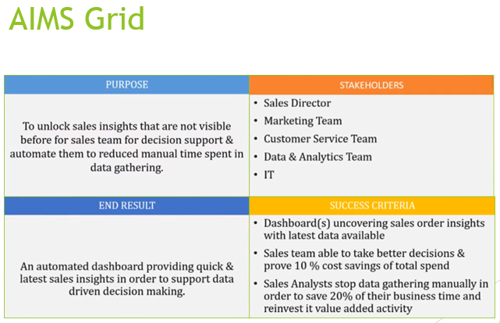

ETL stands for "Extract, Transform, and Load."

In the world of data warehousing, if you need to bring data from multiple different data sources into one, centralized database, you must first:

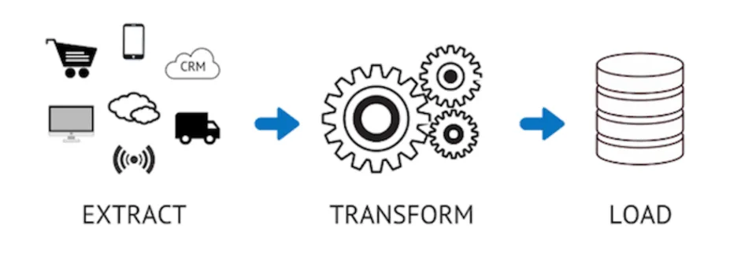

EXTRACT data from its original source

TRANSFORM data by deduplicating it, combining it, and ensuring quality, to then

LOAD data into the target database

ETL tools enable data integration strategies by allowing companies to gather data from multiple data sources and consolidate it into a single, centralized location. ETL tools also make it possible for different types of data to work together.

A typical ETL process collects and refines different types of data, then delivers the data to a data lake or data warehouse such as Redshift, Azure, or Big Query.

A **star schema** is a multi-dimensional data model used to organize data in a database so that it is easy to understand and analyse. Star schemas can be applied to data warehouses, databases, data marts, and other tools. The star schema design is optimized for querying large data sets.

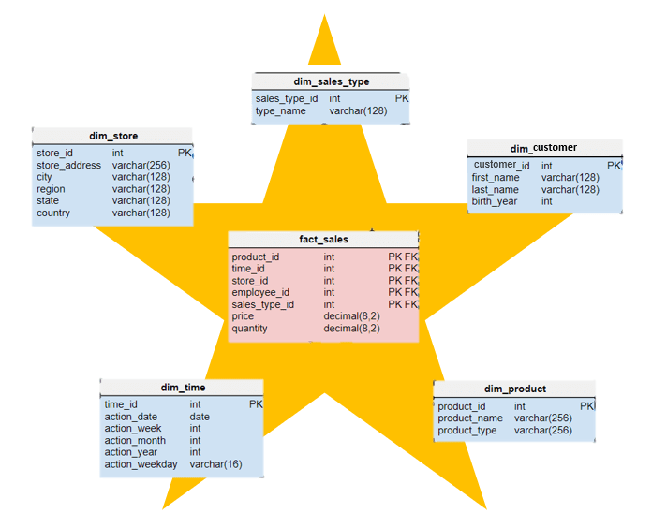

What is the difference between relationship and joins?

* Joins give the option of different join types – inner, outer, left, and right – which handle nonmatches differently. Relationships do not have up-front join types.
* Joins produce a row each time the join criteria are met, which can cause duplication. Relationships do not produce duplication.
* Relationships are automatic and context-aware, while joins are not.
* Relationships can be many-to-many and support full outer joins, while joins do not.

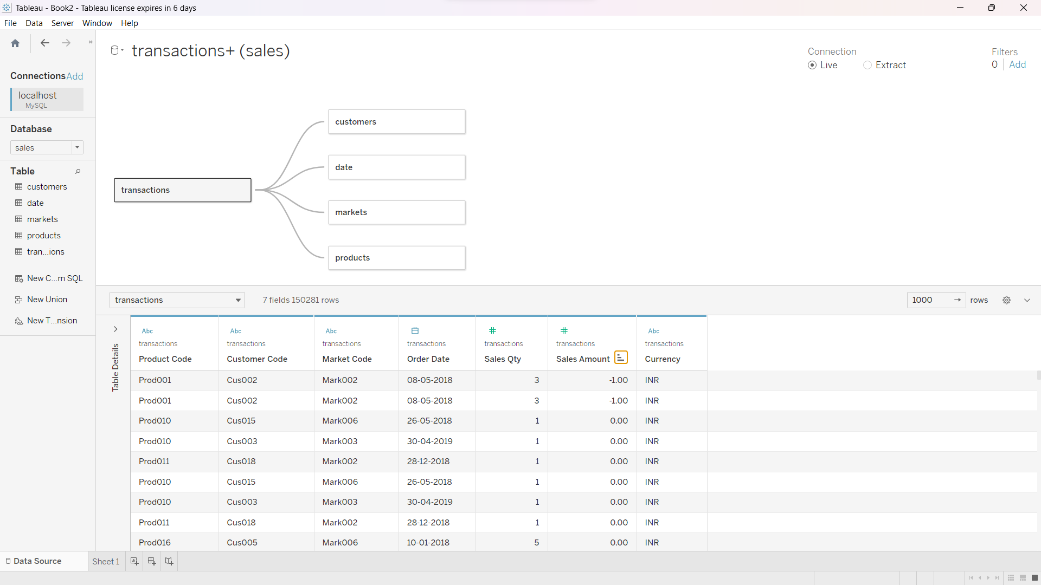

**The goal : Building an interactive dashboard in Tableau.**

The dashboard will display revenue per year and allow users to break down revenues by different regions.

I learned how to create the total revenue component by removing the rows and columns, placing the normalized amount in the text field, and adding a formula to calculate the sum of all sales amounts.

the process of formatting the revenue and sales quantity numbers to be displayed in millions and thousands respectively is quite useful. The revenue and sales quantity by market are created using the normalized amount and market name from the data source. The bars representing the revenue and sales quantity are coloured and labelled with the corresponding amounts, with the labels formatted to be in the middle and in millions/thousands. The steps for creating the sales quantity widget are similar to the revenue widget.

One must learn the process of formatting and customizing the dashboard in Tableau. Like, how to change the font colour, size, and style, as well as hiding unnecessary titles and labels. The focus is on creating visualizations for the top five customers and top five products based on revenue.

For the sales trend sheet, proceed to create a line chart to show revenue by year, using the cy date as the column and normalize amount as the rows. By expanding the cy date, they are able to show quarterly and monthly revenue.

Cy date is a date that indicates the first date of that month. Every transaction that took place in that month have its first date of month as cy date.

It’s very important how to use filters to make the dashboard interactive, allowing the data to be dynamically updated based on user selections. They emphasize the importance of clicking on the filter icon in each component to ensure that the entire dashboard reacts to filter events.

For example : how to filter the dashboard to display specific data for a particular region, such as Delhi?

Explanation : By clicking on a certain button, the chart will only show information related to Delhi, including the top five customers and products for that region. Provided that the filter icon in every widget is activated.

Once the dashboard is ready, it can be exported as a PowerPoint presentation or published to Tableau Online for easy access by managers or stakeholders. Publishing to Tableau Online allows users to view the dashboard through a browser without needing to install the software.

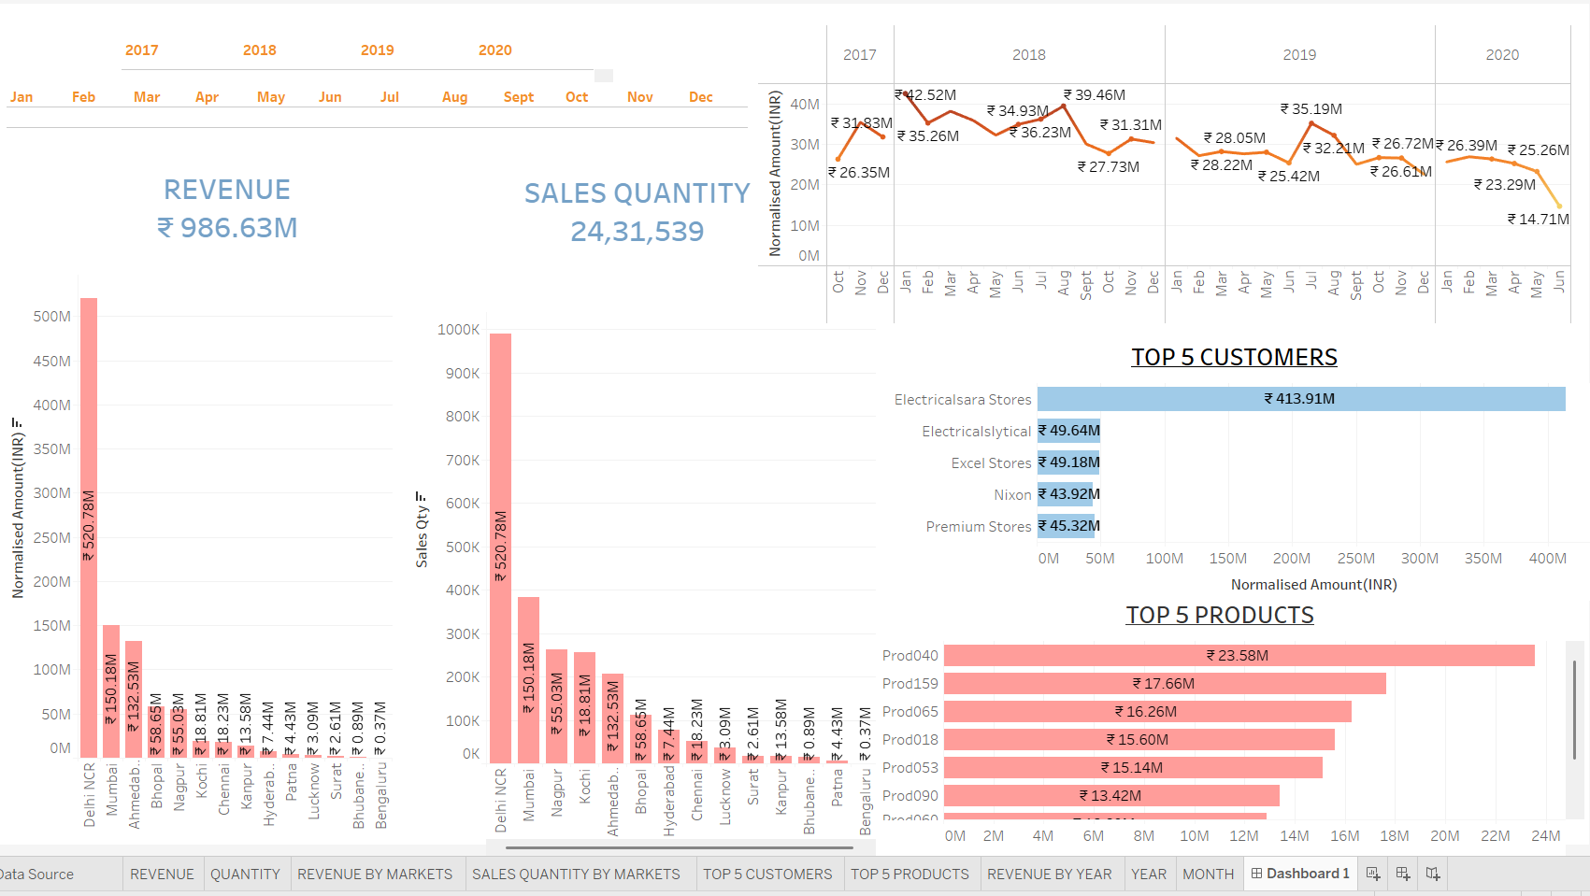

Conclusion:

Tableau is a powerful bi tool which can be utilised to visualise data and draw useful insights.

1. Tableau is a leading data visualization tool that helps users analyse and present data in a visually appealing manner.

2. It offers an intuitive and user-friendly interface, allowing users to create interactive charts, graphs, and dashboards without extensive coding knowledge.

3. Tableau supports connectivity to various data sources, enabling users to combine and transform data for analysis from multiple platforms.

4. Its interactive dashboards facilitate data exploration, drilling down, and collaborative decision-making.

5. Tableau also provides advanced analytics capabilities, including calculations, statistical functions, and data modelling, empowering users to gain deeper insights from their data.